S25-Protocol for grossing gravid hysterectomy specimens with placenta in situ (placenta accreta spectrum)
1. Gather the following information before opening the specimen bucket:
- Clinical/Radiologic diagnoses (Placenta accreta/increta/percreta and uterine location of abnormality, is placenta previa present?)
- Intraoperative assessment of uterine serosa on entering the abdomen (this may not be available depending on timing of the operative report; if you don’t find it prior to grossing, be sure to have it available at the time of signout)
- Whether adjacent structures (e.g. portion of bladder wall) were resected en bloc with the uterus
2. Initial photography: Prior to formalin fixation, take a photo of the anterior and posterior surfaces of the uterus, with a close-up of any areas of disruption
3. Record the following information:
- Weight of the uterus with placenta in situ (if the cervix comes detached from the uterus in the same part, this should be included in the weight)
- 3-dimensional measurements of the uterus (fundus-cervix, anterior-posterior, left-right)
- Hysterotomy site (length and location)
- Appearance of uterine serosa (intact vs disrupted; if the latter, note anatomic location and size of disruption, whether there is a visible C-section scar)
- Whether other structures are present (e.g. fallopian tubes, adherent adipose, bladder wall) and their measurements
4. Ink the specimen(any areas without smooth serosal surface): The right anterior surface = green, left anterior surface = blue, posterior surface = black. Make sure you blot/dry the ink thoroughly, as it tends to run in the best of circumstances and especially will run if there is exposed placental tissue.
5. Call the attending on service to be present for slicing. If the attending on service is not available, call any one of Drs. Berning, Post, or Wolsky.
6. The uterus should be sliced in the axial plane (superior to inferior, perpendicular to the long axis of the uterus) at 2 cm intervals with a long blade and the slices numbered 1 through X, where 1 is the most superior slice. This may be easier to do with one person holding the uterus and the other cutting.
At some point you will encounter the umbilical cord – document the number of vessels, total length of the cord, an approximate insertion site (central/paracentral/marginal/velamentous). The umbilical cord can then be amputated at its insertion site.
7. Document the number of slices, which slices contain the hysterotomy site, and which slices are involved by adherent or invasive placenta. The best way to determine if placenta is abnormally adherent is to gently put traction on the placenta and see if it easily separates from the underlying uterine wall. If it does not readily separate, those are areas of PASD grade 1 (formerly placenta accreta).

Measure the thinnest area of myometrium, and/or note that placental tissue extends to (or through) the serosal surface and which slices contain that finding.
8. Lay out the slices in sequence (slice 1 in upper left corner of image) and photograph (see image below) – take one picture of all sections, with additional close-up photos of any areas of serosal disruption or the area of maximal placental invasion (thinnest myometrium).
9. The slices can be fixed in formalin overnight or grossed the same day, depending on case load, attending preference, or other factors.
10. Additional information required (see also sample dictation below):
- Overall size of the placental disc, to include maximal thickness
- Endometrial thickness in areas away from placental disc
- Myometrial thickness in areas away from placental disc
- Any additional uterine lesions (endometrial/endocervical polyps, leiomyomata, etc.)
- Any placental lesions (e.g. infarcts, thrombi, masses)
11. Take sections for microscopic examination. The number/extent of sections will depend on the pre-operative diagnosis and your findings after slicing the uterus.
Gross pathologic grade 1 (see diagram below): Requires the most extensive sampling of placental:uterine wall interface. Submit 1 cassette (with a single section per cassette) for each slice of uterus which contains adherent placenta. These do not need to be full thickness, as our goal is to assess the presence/absence of decidua at the placental:myometrial interface.
Gross pathologic grade 2 and above: 3 cassettes (1 section per cassette) of placental:myometrial interface at area of maximal thinning of myometrium (or of placental:serosal interface or perforation if present). Additional 3 sections of placental:myometrial interface in regions of grade 1 adherent placenta to evaluate for extent of decidual loss.
All cases should also include:
- Anterior and posterior cervix (if it is a supracervical hysterectomy, an en face section of the anterior and posterior LUS resection margin should be submitted)
- Longitudinal section of inferior-most placenta in relation to LUS/endocervix
- “Uninvolved” endometrium with overlying membranes, generally from the posterior wall or fundus, full thickness (this may require multiple cassettes)
- Additional lesions (e.g. endometrial/endocervical polyp, leiomyoma)
- 2 cross sections of umbilical cord from different areas
- 1 section of full-thickness placental disc without gross abnormalities
- Additional sections to demonstrate any placental lesions (fibrin deposition, infarcts, thrombi, etc.)
- Fallopian tubes (if present) – serially sectioned fimbriated end and representative cross-sections

Sample grossing template:
Received [fresh / in formalin], labeled "[patient's name/MRN/specimen name]” is a [__] g uterus with in situ placenta, [__ ] cm (superior-inferior) x [__] cm (cornu- cornu) x [__] cm (anterior-posterior), [with / without attached cervix / fallopian tubes / ovaries / other structures (give measurements if any of these are present)]. There is a [__] cm hysterotomy site at the [anatomic location – fundus vs LUS, anterior vs posterior] which [has sutures closing the incision, and is without protruding placental tissue].
The serosa [appears intact and without lesions vs with adherent adipose or bladder wall vs appears disrupted with protruding placental tissue]. The anterior right aspect is inked green, the left anterior aspect inked blue, and the posterior aspect inked black. The uterus is sliced axially from superior to inferior into [__] sections, with section #1 representing the fundus. There is a [__] cm trivascular umbilical cord inserted [centrally/paracentrally/marginally/velamentously] onto the placental disc (include distance of membranous vessels if velamentous insertion). The fetal surface is [purple-blue and without lesions], with vessels [extending to the disc edge]. The membranes are [tan and clear vs green tinged vs brown]. The placental parenchyma, present in slices [__] through [__], ranges in thickness from [__] to [__] cm. ((Describe appearance of parenchyma, as well as any lesions that are seen)). In slices [__] through [__], there is [abnormal adherence without myometrial thinning / thinned myometrium to a thickness of __ / absent myometrium with only serosa covering placenta / disrupted serosa with protrusion of placental tissue].
Endometrium away from the placental implantation is covered by membranes, with a total thickness of [__] cm. The myometrial thickness away from placental disc ranges from [__] to [__] cm thick. (Also describe additional lesions such as polyps or leiomyomata)
Gross photographs are taken per protocol and representative sections are submitted as follows:

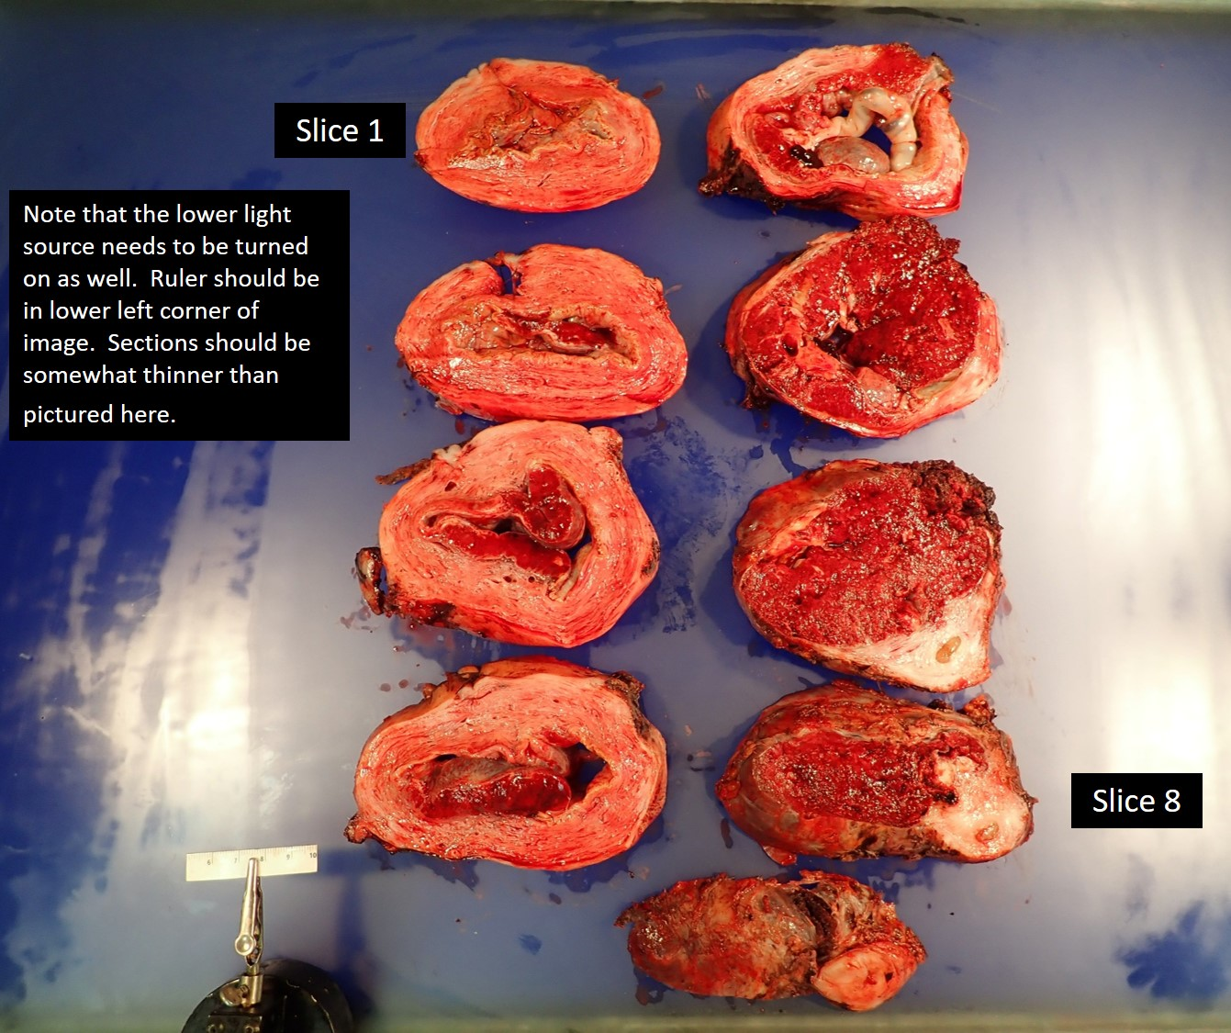

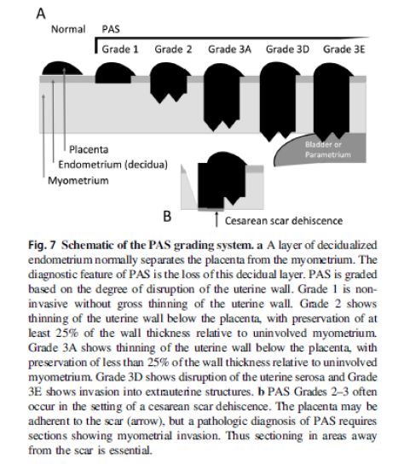
(From Hecht 2020)
References:
Hecht JL, et al. Classification and reporting guidelines for the pathology diagnosis of placenta accreta spectrum (PAS) disorders: recommendations from an expert panel. 2020 Modern Pathology
Jauniaux E, et al. FIGO Placenta Accreta Diagnosis and Management Expert Consensus Panel. FIGO consensus guidelines on placenta accreta spectrum disorders: Introduction. Int J Gynaecol Obstet. 2018;140(3):261-264.

